**Aneesh Pavan Prodduturu**

**Q: How do I create gear in Houdini SideFX?**

**A:**

Firstly, open the Houdini Apprentice.



This interface consists of three panes: the Viewers pane, the Parameters pane, and the Network pane.

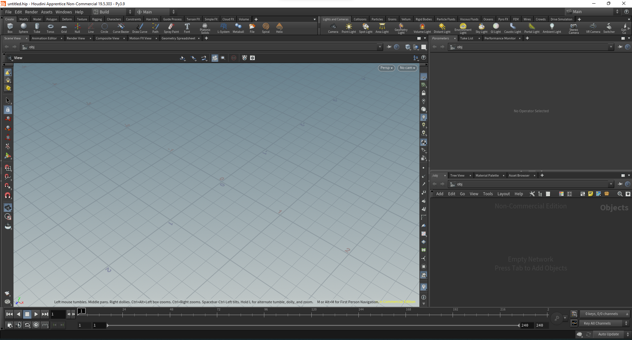

To get started, we first need to change the network pane from objects to geometry by right-clicking, adding geometry in the pane, and double-clicking on the node to turn the pane into geometry.

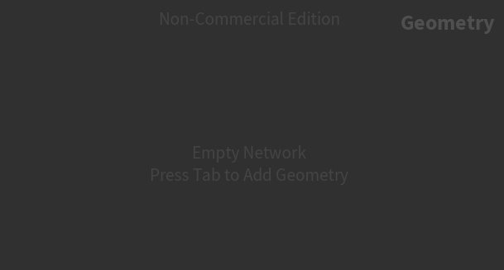

Now, we can right-click on the pane and add a circle (primitive) to the network pane.

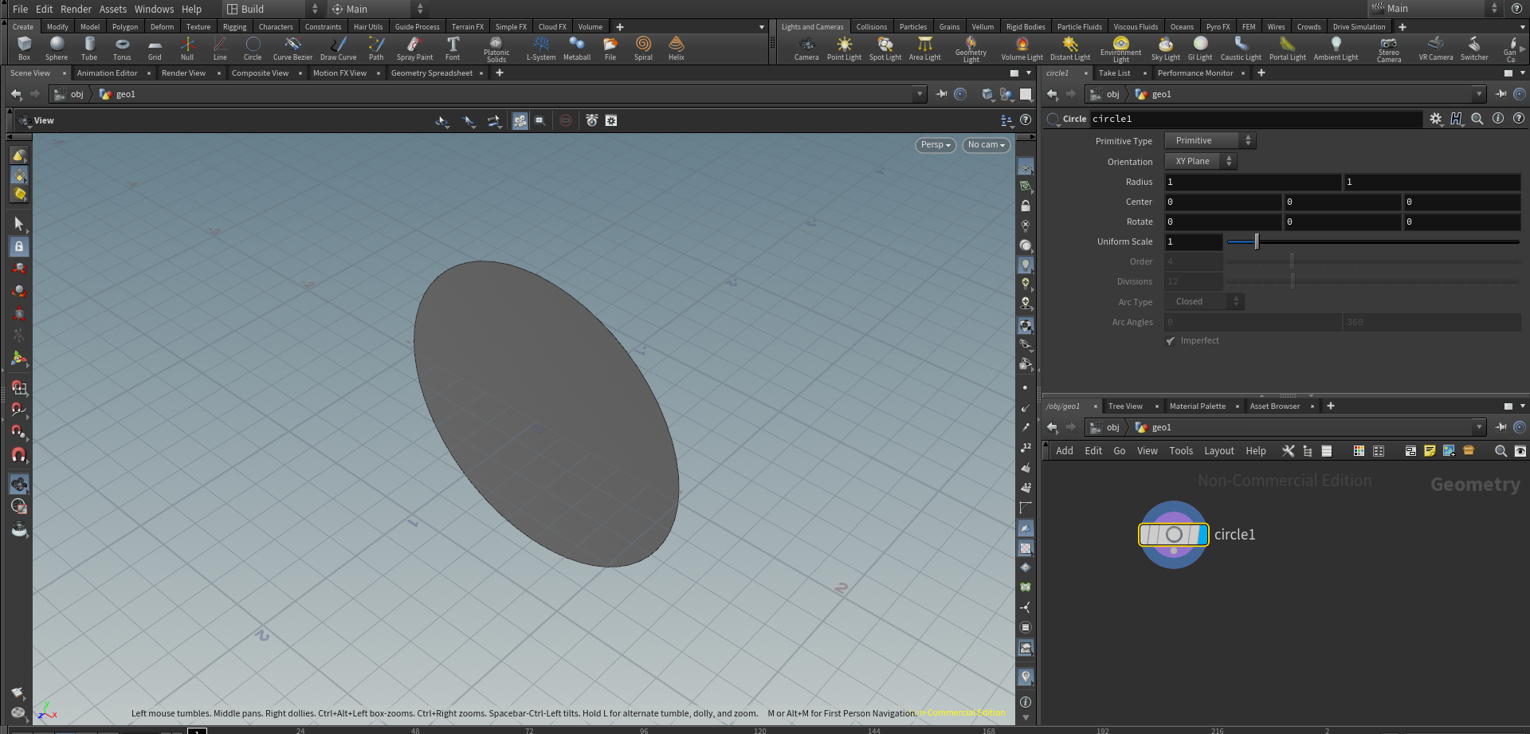

Convert the primitive type from primitive to the polygon.

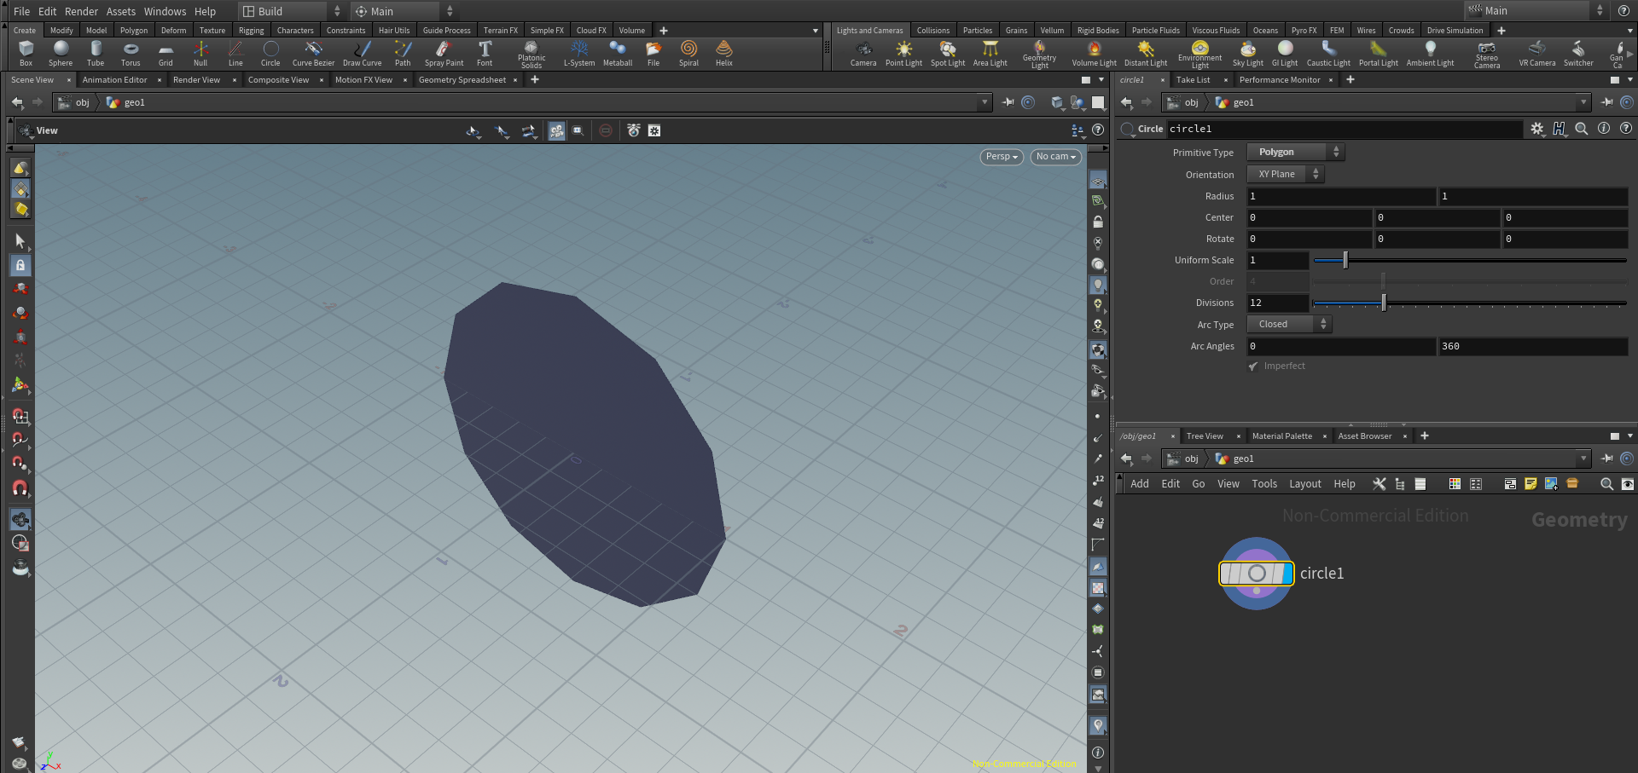

Also, change the orientation to the ZX plane for better visibility and make divisions, for example, 80. And then proceed by adding transform in the network pane, which will look like this.

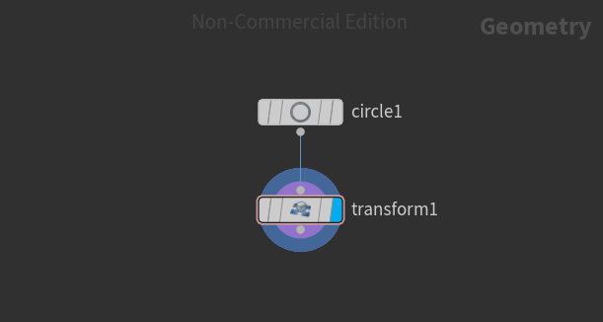

In the parameter pane, add the group as 0-80:4 to divide the circle into parts and change the group type to points. Then add poly extrude to the network pane and add the distance in negative 0.5 to bring the thickness to the circle which makes it look like a gear with spikes.

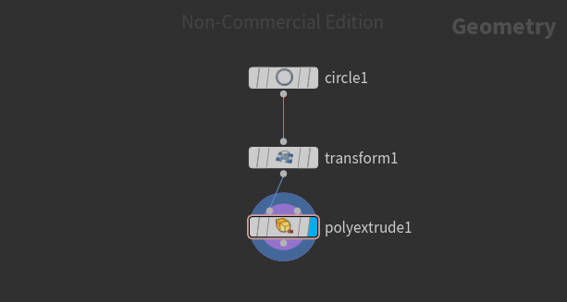

This is how it looks in the viewers' pane.

